Review Questions
1. What goes into the interface file? Implementation file? Application file?
2. How does code compile?
3. Create a diagram of the process of source code to compiled object.

Review Answers
1. The class definition and the declarations for a function, overloading operator go in the interface file. The definition for a function, a friend function, a member function, and overloading operator goes in an implementation file. The main part of the table goes in the application file.
2. The code written is transformed into machine language and then compiles.
3.
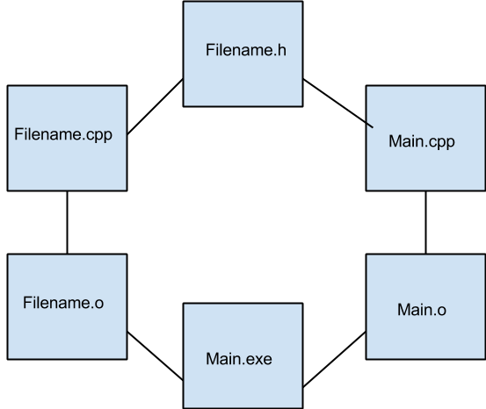

References
http://faculty.cs.niu.edu/~mcmahon/CS241/Notes/compile.html
https://www.youtube.com/watch?v=NEIYmUW9Aig

